EUROPEAN COMMISSION
HORIZON 2020 PROGRAMME - TOPIC H2020-LC-BAT-2020

Solutions for large batteries for waterborne transport

GRANT AGREEMENT No. 963560

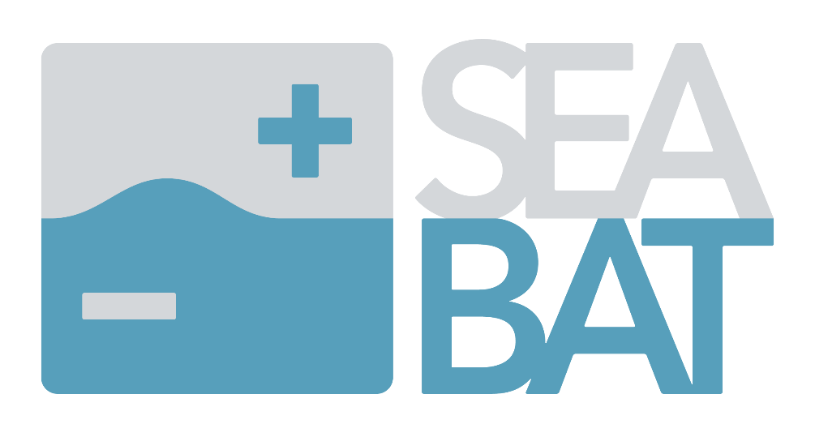

D7.3 Initial business and exploitation plan

Deliverable No. | SEABAT D7.3
Deliverable Title | plan
Deliverable Date | 2022-12-31
Dissemination level | CO
Author | Cor van der Zweep (UNR), Jeroen Stuyts (FM), Roel Van Thillo (FM) | 2022-12-01
WP leader | Alfonso Carneros -WPL7 (SOERMAR)
Reviewers | Jose Maria Canales (MGEP)  Jeroen Stuyts (FM) | 2022-12-12  2022-12-20
Coordinator | Jeroen Stuyts (FM) | 2022-12-20
Report details

Document History
Version | Date | Author | Remarks
V1.0 | 16-07-2021 | Cor van der Zweep | Initial plan
V1.1 | 10/11/2022 | Jeroen Stuyts | Update
V1.2 | 05/12/2022 | Roel Van Thillo | Update
V1.3 | 20/12/2022 | Roel Van Thillo | Update after review
V2.0 | 27/12/2022 | Cor van der Zweep | Final editing and ready for final submission

Project Abstract
The goal of the SEABAT project is to develop a full-electric maritime hybrid battery concept that is based on:
- Modularly combining high-energy batteries and high-power batteries,
- novel converter concepts and
- production technology solutions derived from the automotive sector.

The modular approach will reduce component costs (battery cells, convertors) so that unique ship designs can profit from economies of scale by using standardised low-cost components. The concept will be suitable for ships requiring up to 1 MWh of storage or more.

Public summary

Within this deliverable (D7.3), the Initial business and exploitation plan is introduced for the SEABAT project.

This will be built upon the first proposed exploitation plan as included in section 2 of the SEABAT proposal and on D7.2 ‘dissemination and communication objectives’, describing the different audiences and what tools will be used to reach them.

The initial chapter is the overall goal and objective of the tasks in WP7 related to the exploitation of results.

The second part will deal with the exploitation and business plans with the results developed in the SEABAT project. A reference in this part will be made towards WP1 results, market needs and regulations.

The preliminary exploitable plan comprises of exploitation components, exploitation paths and levels of exploitation. The plan confirms the high value creation potential of the SEABAT project. Regular updates will take place in the course of the project with a final exploitation plan due at the end of the project.

Acknowledgements and disclaimer
The author(s) would like to thank the partners in the project for their valuable comments on previous drafts and for performing the review.

Project partners:
# | Partner | Partner Full Name
1 | FM | FLANDERS MAKE
2 | DAMEN | SCHEEPSWERF DAMEN GORINCHEM BV
2.1 | DGS | Damen Global support BV
2.2 | DRDI | Damen Research Development & Innovation BV
3 | FCSI | FINCANTIERI SI SPA
4 | RINA | RINA SERVICES SPA
5 | SOERMAR | FUNDACION CENTRO TECNOLOGICO SOERMAR
6 | VARD | VARD ELECTRO AS
7 | ABEE | AVESTA BATTERY & ENERGY ENGINEERING
8 | IMECAR | IMECAR ELEKTRONIK SANAYI VE TICARET LIMITED SIRKETI
9 | UNR | UNIRESEARCH BV
10 | CEA | COMMISSARIAT A L ENERGIE ATOMIQUE ET AUX ENERGIES ALTERNATIVES
11 | Fraunhofer | FRAUNHOFER GESELLSCHAFT ZUR FOERDERUNG DER ANGEWANDTEN FORSCHUNG E.V.
12 | IKERLAN | IKERLAN S. COOP
13 | MGEP | MONDRAGON GOI ESKOLA POLITEKNIKOA JOSE MARIA ARIZMENDIARRIETA S COOP
14 | SINTEF | SINTEF ENERGI AS
15 | POLITO | POLITECNICO DI TORINO
Table 5.1.1 List of project partners

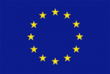
Copyright ©, all rights reserved. This document or any part thereof may not be made public or disclosed, copied or otherwise reproduced or used in any form or by any means, without prior permission in writing from the SEABAT Consortium. Neither the SEABAT Consortium nor any of its members, their officers, employees or agents shall be liable or responsible, in negligence or otherwise, for any loss, damage or expense whatever sustained by any person as a result of the use, in any manner or form, of any knowledge, information or data contained in this document, or due to any inaccuracy, omission or error therein contained.

All Intellectual Property Rights, know-how and information provided by and/or arising from this document, such as designs, documentation, as well as preparatory material in that regard, is and shall remain the exclusive property of the SEABAT Consortium and any of its members or its licensors. Nothing contained in this document shall give, or shall be construed as giving, any right, title, ownership, interest, license or any other right in or to any IP, know-how and information.

This project has received funding from the European Union’s Horizon 2020 research and innovation program under grant agreement No 963560. The information and views set out in this publication does not necessarily reflect the official opinion of the European Commission. Neither the European Union institutions and bodies nor any person acting on their behalf, may be held responsible for the use which may be made of the information contained therein.

